**Table of Contents**

1. Executive Summary 3

1.1 Project Overview 3

1.2 Purpose and Scope of this Specification 3

2. Product/Service Description 3

2.1 Product Context 3

2.2 User Characteristics 3

2.3 Assumptions 3

2.4 Constraints 4

7.1 Dependencies 4

11. Requirements 4

11.1 Functional Requirements 4

11.2 Security 5

11.2.1 Protection 5

11.2.2 Authorization and Authentication 5

11.3 Portability 5

12. Requirements Confirmation/Stakeholder sign-off 5

13. System Design 5

13.1 Algorithm 5

13.2 System Flow 5

13.3 Software 6

13.4 Hardware 6

13.5 Test Plan 6

13.6 Task List/Gantt Chart 7

13.7 Staffing Plan 7

# Executive Summary

## Project Overview

This project is about using robotics to complete a series of tasks. The intended audience is the classroom in which the project was given and specifically, our classmates and professor. We also could use these robots to introduce new people into coding when everything is fully functional; once people see how cool and fulfilling it is to program robots to move in a controlled environment, we can draw more attention to software/computer programming.

## Purpose and Scope of this Specification

The intended purpose of this project is to follow a series of steps and processes given to us by our instructor. This includes:

* Following the agility course with proper accuracy at an appropriate speed
* Moving around the course and jumping over a ramp
* Keeping a consistent speed while traversing around the course and following all steps in the Sphero program
* Showcase different angles and speeds to reach desired goal of getting a strike

# Product/Service Description

The general factors that affect our product is the programming of the robot itself and how computers utilize this hardware. We also use the website Sphero.edu and a Bluetooth connection to run block code (to make the robot function the way we want). Our robot is among the latest models (Bolt), but overall, with proper computer/phone software, a Sphero robot, and a stable Bluetooth connection, this project should be possible to complete.

## Product Context

Our robots can be compared to other robot services/products, due to the simplistic nature of how easy it is to connect. There are many other robotic sites that come with purchasable robots/machines to control, however, the robots we are using, and the user interface run by Sphero.edu is a completely independent service. The website is run over Bluetooth connection and is very easy to use when a Sphero robot is present; the site they use as well Is their own in terms of the block code and doesn’t rely on other sites such as code.org.

## User Characteristics

* Student/Classmate – Age (18 – 23) – College Education Level – Software/Computer Science Expertise – First to second year work in robotics and programming
* Teacher – Age (30 – 80) – Masters/Bachelors/PhD level Education – Software/Computer Science expert – Multiple years working in the field of robotics/software development
* Regular consumer – Age (5 – 70) – Any education level – Any major/profession – New or existing knowledge of programming/software

## Assumptions

Any of the following assumptions will affect the requirements. A brief description to explain each assumption may help as well.

* Use of a windows computer (This will not affect the robots’ capabilities, but the sensory data portion of Sphero.edu will be affected. It is easier to use this website/app on Mac)
* User Expertise (This will not be a complete deal breaker, since any knowledge range can be used with the robot, but some functions/code will appear difficult and making the robot complete a certain task will be harder with less knowledge)
* Chromebooks and iPad devices are compatible with the Sphero robots (Recommended to use Windows computers or MacBook devices with the capabilities of IOS 14 and up)

## Constraints

* Parallel operation with an old system (IOS 14 and below + Windows 12 and below)
* Room availability (the product will not complete all tasks without proper preparation times. If we are unable to meet at least 3 times, the results will not show as intended)
* Lack of access to the Sphero Website, unprofessional management, and faulty security (all these factors will prohibit the best possible work achieved and if present can be detrimental)
* Criticality of the application (if the Sphero robot itself was to shut down or malfunction, the work process may be affected)
* System resources (bad battery usage of our main computer, the failure to bring work devices, and limited storage to store our documents)

## Dependencies

* The workspace reception being effective enough to run the program code
* The Wi-Fi adapter/Intel graphics cards of our computers (Having accessibility to Apple’s EN0, and Mac OS software)
* Robot designed by Sphero or another robot with the capabilities to run through the main website

# Requirements

**Priority Definitions**

* Priority 1 – Must have an established Bluetooth/Wi-Fi connection with Sphero robot and website
* Priority 2 – Sufficient computer with adequate processor, CPU, and graphics cards (should be a Mac OS system for best production/accessibility to sensory data and graphs); Mac is not needed, Windows is sufficient but does not give entire access to website
* Priority 3 – More advanced type of robot, course picture/walkthrough, Google documents that list every step along the testing process (which can be done with the “notes” portion of the Sphero website). In our case we used Microsoft Word and draw.io to document all our progress.
* Priority 4 - Calibrate the machine in order to follow directions of the course
* Priority 5 - Test robot enough times to perfect the course
* Priority 6 - Record video of Sphero robot traversing the course accurately

**Extra rules/priorities followed:**

* Priority 7 – Ensure robot avoids obstacles
* Priority 8 – Jump over ramp and known down markers

## Functional Requirements

| **Req#** | **Requirement** | **Comments** | **Priority** | **Date Reviewed** | **SME Reviewed / Approved** |
| --- | --- | --- | --- | --- | --- |
| AGI_01 | Start at beginning square | Simple; we just needed to place the robot in the spot | 1 | 11/28/23 | 11/29/23 |
| AGI_02 | Move along first path (straight angle) | Simple use of angles to follow the path | 2 | 11/28/23 | 11/29/23 |
| AGI_03 | Complete first turn at 0 degrees | Proved to be easy and allowed us to base the outcome of the code for further parts | 3 | 11/28/23 | 11/29/23 |
| AGI_04 | Complete second turn at 90 degrees | We needed to use roll blocks (90 degrees) in order to follow path | 4 | 11/28/23 | 11/29/23 |
| AGI_05 | Complete third turn at 0 degrees again | Repetition of first turn | 5 | 11/28/23 | 11/29/23 |
| AGI_06 | Roll 93 degrees at 242 speed | Used 93 degrees to go straight down the ramp path | 6 | 11/28/23 | 11/29/23 |
| AGI_07 | Jump over ramp and land back on the course | Needed speed to jump over ramp and land robot | 7 | 11/28/23 | 11/29/23 |
| AGI_08 | Roll straight at 218 degrees (at 250 speed) to knock down markers | Once landed, needed a proper angle and enough speed to known down markers | 8 | 11/28/23 | 11/29/23 |

## Security

### Protection

* Ensuring only group members can access and edit repository contents.
* Sphero must be within range of the host computer to operate remotely.
* Programs used for the system must be trusted and free of malware and whatnot.

### Authorization and Authentication

* Each group member must accept the invitation to the proper repositories to be given permission to edit repository contents.
* Login confirms the identity of the person (using the correct username and the correct password) and grants access to the site under their respective username.

## Portability

* The Sphero application provides its own block coding program for robot operation.
* Each of the three group members mainly uses a different operating system.
  + Windows, MacOS, and ChromeOS are all compatible with Sphero to different extents.
* Computers must connect with the robot and follow the block code effectively regardless of the operating system used.
* The course is a rectangular track marked by blue duct tape on the floor of a classroom of an appropriate size.

# Requirements Confirmation/Stakeholder sign-off

|  |  |  |
| --- | --- | --- |
| **Meeting Date** | **Attendees (name and role)** | **Comments** |
| 11/28/23 | Jalen (manager) Jimmy (video recorder) | This meeting proved to be work-efficient and allowed us to construct block code and video |
| 11/29/23 | Jalen (manager) Jimmy (video recorder) Jared (flowchart/algorithm creator) | This meeting allowed us finalize the third part of the project (Sprint 3) |

# 

# System Design

## Algorithm

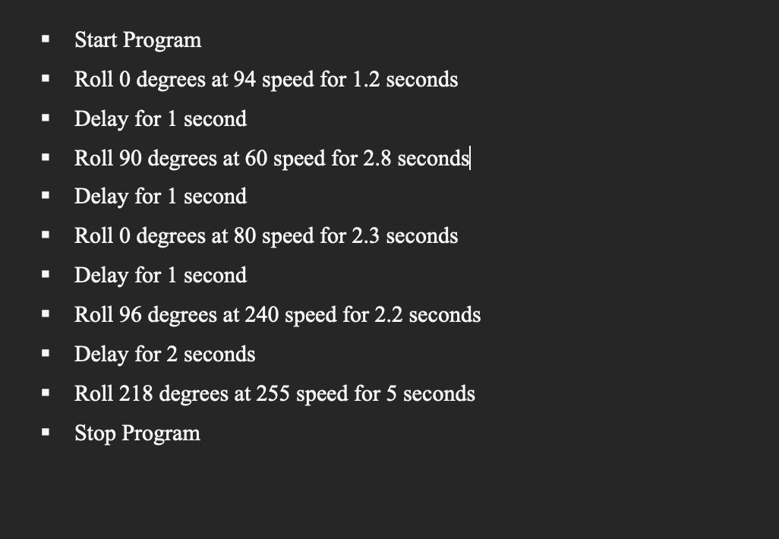

## System Flow

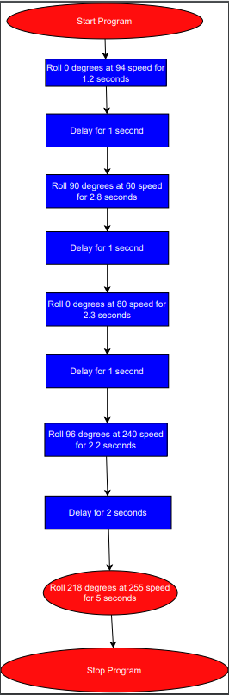

**(Zoom page to 200%)**

## Software

Sphero 6.6.0 | Operates on Java | Written to give sphere-shaped robots the ability of motion by drawing paths through the app via block code.

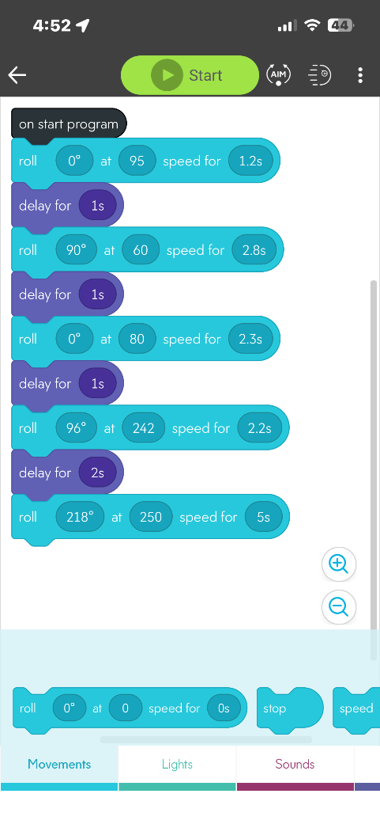

## Hardware

MacBook Pro 15-Inch, 2019 | Processor 2.3 GHz 8-Core Intel Core i9 | Graphics Intel UHD Graphics 630 1536 MB | Memory 16 GB 2400 MHz DDR4 | MacOS Ventura 13.5.2

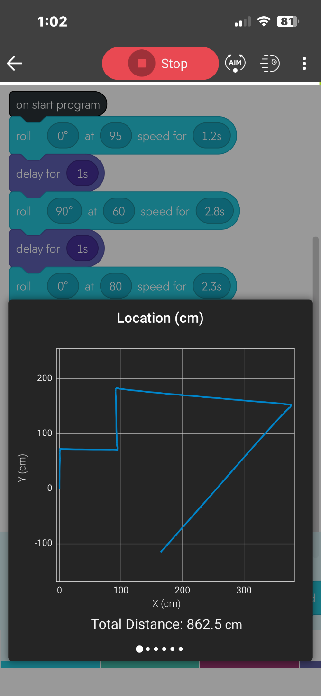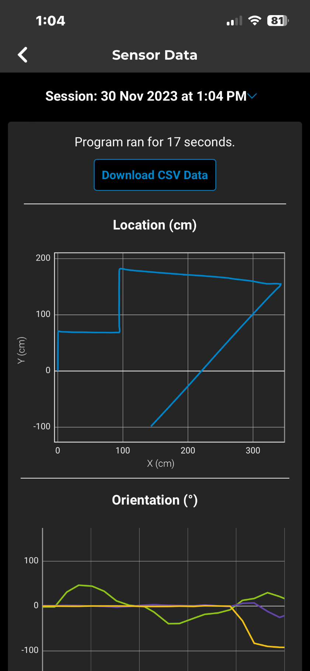

## Test Plan

| **Reason for Test Case** | **Test Date** | **Expected Output** | **Observed Output** | **Staff Name** | **Pass/Fail** |
| --- | --- | --- | --- | --- | --- |
| Start at beginning square and follow first pathway accurately | 11/28/23 | Expected to perform this step a few times in order to perfect the initial movement of the robot on the course | Had to position robot in beginning square multiple times to get wanted results | Jimmy, Jalen | Fail |
| Start at beginning square and follow first pathway accurately | 11/28/23 | Expected to understand where the robot should be placed in order to perfect the whole course | Rolled far left and positioned robot to hit first bottle | Jimmy, Jalen | Fail |
| Start at beginning square and follow first pathway accurately | 11/28/23 | Because of the two failed attempts, we drew on the floor a spot where we aim and run the block code | Followed path accurately and set up well for next turn | Jimmy, Jalen | Pass |
| Avoid first bottle then make first turn | 11/28/23 | Due to initial placement of robot, we expected the ball to avoid first bottle and stay on path | Did exactly what we expected | Jimmy, Jalen | Pass |
| Make second turn and avoid second bottle | 11/28/23 | Due to initial placement of robot and successful first turn, we expected robot to follow path with ease | Tape messed up turn pattern of robot and required increase in speed | Jimmy, Jalen | Fail |
| Make second turn and avoid second bottle | 11/28/23 | We expected robot to traverse the course more accurately with new adjustments to speed and duration | Did exactly what we needed to set up third turn very well | Jimmy, Jalen | Pass |
| Make third turn and avoid third bottle to set up for ramp | 11/29/23 | We expected the robot to repeat first two turns at higher speed | Did exactly what we expected, but degree radius was slightly off | Jimmy, Jalen, Jared | Fail |
| Make third turn and avoid third bottle to set up for ramp | 11/29/23 | We expected robot to turn more accurately based on previous observation | Due to a 6 degree increase in turn radius (from 90 to 96 degrees) the ball fared more accurately on course | Jimmy, Jalen, Jared | Pass |
| Head straight, jump over ramp, and land | 11/29/23 | After third turn of 96 degrees, we expected robot to jump over ramp and land smoothly | Robot jumped over ramp slightly early from desired spot with 90-degree turn radius (which did not affect much overall) | Jimmy, Jalen, Jared | Pass |
| Travel along path to knock down markers | 11/29/23 | We used a repeated measurement to knock down markers | Proved wrong and required a different angle | Jimmy, Jalen, Jared | Fail |
| Travel along path to knock down markers | 11/29/23 | After some math, we changed the turn radius to 218 degrees to aim at the markers with precision and increased speed to 250 for more force | Executed properly and knocked down all 10 markers (strike) | Jimmy, Jalen, Jared | Pass |

## Task List/Gantt Chart

<https://onedrive.live.com/edit?id=989AFAE5454A455B!222&resid=989AFAE5454A455B!222&ithint=file%2cxlsx&authkey=!AJI09z-bLqPmW8g&wdo=2&cid=989afae5454a455b>

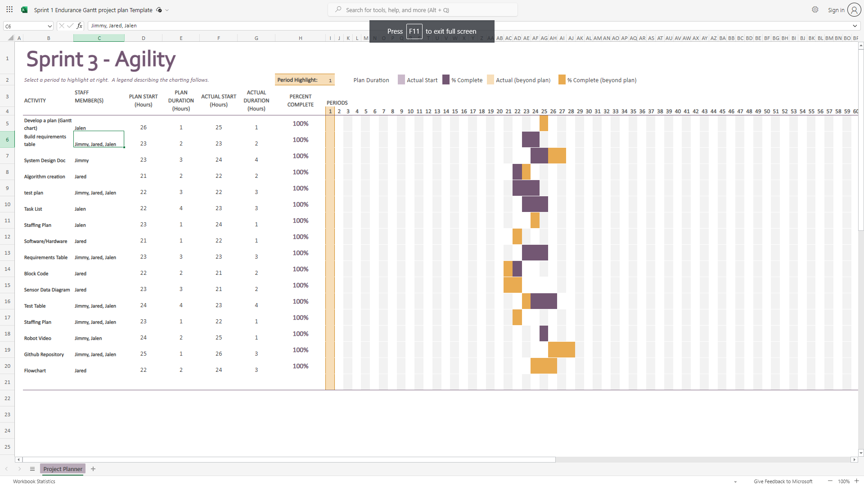

## Staffing Plan

| Name | Role | Responsibility | Reports To |
| --- | --- | --- | --- |
| Jalen | Project Manager | * Complete Gantt Chart * Complete Staff Plan * Complete block code and sensory data | Group |
| Jimmy | Repository Host | * Edit and submit system design document * Record robot video(s) | Group |
| Jared | Programmer | * List requirements and complete requirements table * Create algorithm and flowchart | Group |